**Unit II - Process Management**

**Scheduling Algorithms:**

In a system, there are a number of processes that are present in different states at a particular time. Some processes may be in the waiting state, others may be in the running state and so on. PU uses some kind of process scheduling algorithms to select one process for its execution amongst so many processes. The process scheduling algorithms are used to maximize CPU utilization by increasing throughput.

These algorithms are either **non-preemptive or preemptive**. Non-preemptive algorithms are designed so that once a process enters the running state, it cannot be preempted until it completes its allotted time, whereas the preemptive scheduling is based on priority where a scheduler may preempt a low priority running process anytime when a high priority process enters into a ready state.

Different criteria to check when considering the **"best"** scheduling algorithm, they are

* CPU Utilization: To make out the best use of CPU and not to waste any CPU cycle, CPU would be working most of the time (Ideally 100% of the time). Considering a real system, CPU usage should range from 40% (lightly loaded) to 90% (heavily loaded.)
* Throughput: It is the total number of processes completed per unit time or rather say total amount of work done in a unit of time. This may range from 10/second to 1/hour depending on the specific processes.
* Turnaround Time: It is the amount of time taken to execute a particular process, i.e. The interval from time of submission of the process to the time of completion of the process (Wall clock time).
* Waiting Time: The sum of the periods spent waiting in the ready queue amount of time a process has been waiting in the ready queue to acquire get control on the CPU.
* Load Average: It is the average number of processes residing in the ready queue waiting for their turn to get into the CPU.
* Response Time: Amount of time it takes from when a request was submitted until the first response is produced. Remember, it is the time till the first response and not the completion of process execution (final response).

## First Come First Serve (FCFS)

* Jobs are executed on first come, first serve basis.
* It is a non-preemptive, pre-emptive scheduling algorithm.
* Easy to understand and implement.
* Its implementation is based on FIFO queue.
* Poor in performance as average wait time is high.

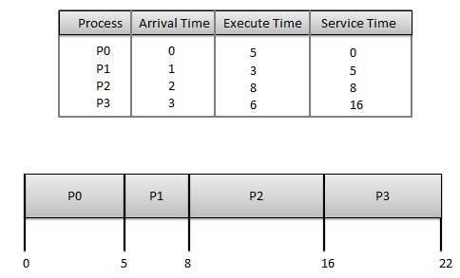

**Wait time** of each process is as follows –

|  |  |
| --- | --- |
| **Process** | **Wait Time : Service Time - Arrival Time** |
| P0 | 0 - 0 = 0 |
| P1 | 5 - 1 = 4 |
| P2 | 8 - 2 = 6 |
| P3 | 16 - 3 = 13 |

Average Wait Time: (0+4+6+13) / 4 = 5.75

## Shortest Job First (SJF)

* This is also known as **shortest job next**, or SJN
* This is a non-preemptive, pre-emptive scheduling algorithm.
* Best approach to minimize waiting time.
* Easy to implement in Batch systems where required CPU time is known in advance.
* Impossible to implement in interactive systems where required CPU time is not known.
* The processer should know in advance how much time process will take.

Given: Table of processes, and their Arrival time, Execution time

|  |  |  |  |
| --- | --- | --- | --- |
| **Process** | **Arrival Time** | **Execution Time** | **Service Time** |
| P0 | 0 | 5 | 0 |
| P1 | 1 | 3 | 5 |
| P2 | 2 | 8 | 14 |
| P3 | 3 | 6 | 8 |

**Waiting time** of each process is as follows −

|  |  |
| --- | --- |
| **Process** | **Waiting Time** |
| P0 | 0 - 0 = 0 |
| P1 | 5 - 1 = 4 |
| P2 | 14 - 2 = 12 |
| P3 | 8 - 3 = 5 |

Average Wait Time: (0 + 4 + 12 + 5)/4 = 21 / 4 = 5.25

## Priority Based Scheduling

* Priority scheduling is a non-preemptive algorithm and one of the most common scheduling algorithms in batch systems.
* Each process is assigned a priority. Process with highest priority is to be executed first and so on.
* Processes with same priority are executed on first come first served basis.
* Priority can be decided based on memory requirements, time requirements or any other resource requirement.

Given: Table of processes, and their Arrival time, Execution time, and priority. Here we are considering 1 is the lowest priority.

|  |  |  |  |  |
| --- | --- | --- | --- | --- |
| **Process** | **Arrival Time** | **Execution Time** | **Priority** | **Service Time** |
| P0 | 0 | 5 | 1 | 0 |
| P1 | 1 | 3 | 2 | 11 |
| P2 | 2 | 8 | 1 | 14 |
| P3 | 3 | 6 | 3 | 5 |

**Waiting time** of each process is as follows −

|  |  |
| --- | --- |
| **Process** | **Waiting Time** |
| P0 | 0 - 0 = 0 |
| P1 | 11 - 1 = 10 |
| P2 | 14 - 2 = 12 |
| P3 | 5 - 3 = 2 |

Average Wait Time: (0 + 10 + 12 + 2)/4 = 24 / 4 = 6

## Round Robin Scheduling

* Round Robin is the preemptive process scheduling algorithm.
* Each process is provided a fix time to execute, it is called a **quantum**.
* Once a process is executed for a given time period, it is preempted and other process executes for a given time period.
* Context switching is used to save states of preempted processes.

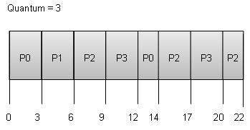

**Wait time** of each process is as follows −

|  |  |
| --- | --- |
| **Process** | **Wait Time : Service Time - Arrival Time** |
| P0 | (0 - 0) + (12 - 3) = 9 |
| P1 | (3 - 1) = 2 |
| P2 | (6 - 2) + (14 - 9) + (20 - 17) = 12 |
| P3 | (9 - 3) + (17 - 12) = 11 |

Average Wait Time: (9+2+12+11) / 4 = 8.5

## Multiple-Level Queues Scheduling

Multiple-level queues are not an independent scheduling algorithm. They make use of other existing algorithms to group and schedule jobs with common characteristics.

* Multiple queues are maintained for processes with common characteristics.
* Each queue can have its own scheduling algorithms.
* Priorities are assigned to each queue.

For example, CPU-bound jobs can be scheduled in one queue and all I/O-bound jobs in another queue. The Process Scheduler then alternately selects jobs from each queue and assigns them to the CPU based on the algorithm assigned to the queue.